**Task 01**

**#include<iostream>**

**using namespace std;**

**bool searchfun(int siz, int src, int *array)**

**{**

**bool a;**

**for(int i=0; i<siz; i++)**

**{**

**if(src==(array[i]))**

**{**

**a=true;**

**}**

**else**

**{**

**a=false;**

**}**

**}**

**return a;**

**}**

**int main()**

**{**

**int search;**

**int size=10;**

**int arrmarks[size];**

**for(int i=0; i<size; i++)**

**{**

**cout<<"Enter marks : ";**

**cin>>arrmarks[i];**

**}**

**cout<<"Enter marks to search : ";**

**cin>>search;**

**if((searchfun(size,search,arrmarks))==true)**

**{**

**cout<<search<<" is found.";**

**}**

**else**

**{**

**cout<<search<<" is not found.";**

**}**

**return 0;**

**}**

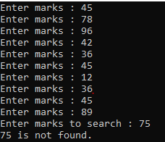

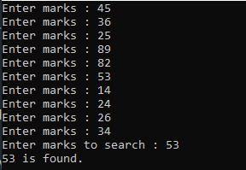

**Task 02**

**#include<iostream>**

**using namespace std;**

**double findmax(int size, double array[])**

**{**

**double max;**

**for(int i=0; i<size; i++)**

**{**

**if(i==0)**

**{**

**max=array[i];**

**}**

**else if(array[i]>max)**

**{**

**max=array[i];**

**}**

**}**

**return max;**

**}**

**int main()**

**{**

**int size;**

**cout<<"Enter size of an array : ";**

**cin>>size;**

**double array[size];**

**for(int i=0; i<size; i++)**

**{**

**cout<<"Enter value"<<i+1<<" : ";**

**cin>>array[i];**

**}**

**cout<<"Maximum value in the array is : "<<findmax(size,array)<<endl;**

**return 0;**

**}**

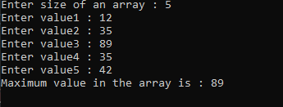

**Task 03**

**#include<iostream>**

**using namespace std;**

**int sum(int ar[],int sz)**

**{**

**int sum=0;**

**for(int i=0; i<sz; i++)**

**{**

**sum+=ar[i];**

**}**

**return sum;**

**}**

**void normalarray(int ar1[],double ar2[],int siz)**

**{**

**double tot;**

**tot=sum(ar1,siz);**

**for(int i=0; i<siz; i++)**

**{**

**ar2[i]=(ar1[i])/tot;**

**}**

**cout<<"\nElements of second array are : ";**

**for(int i=0; i<siz; i++)**

**{**

**cout<<ar2[i]<<" ";**

**}**

**}**

**int main()**

**{**

**int size;**

**cout<<"Enter size of an array : ";**

**cin>>size;**

**double array[size];**

**int arr[size];**

**for(int i=0; i<size; i++)**

**{**

**cout<<"Enter value"<<i+1<<" : ";**

**cin>>arr[i];**

**}**

**cout<<"Elements of first array : ";**

**for(int i=0; i<size; i++)**

**{**

**cout<<arr[i]<<" ";**

**}**

**normalarray(arr,array,size);**

**return 0;**

**}**

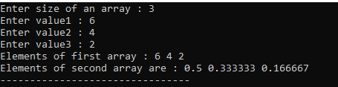

**Task 04**

**#include<iostream>**

**using namespace std;**

**int main()**

**{**

**int a[4][5];**

**for(int i=0; i<4; i++)**

**{**

**for(int j=0; j<5; j++)**

**{**

**cout<<"Enter number : ";**

**cin>>a[i][j];**

**}**

**cout<<endl;**

**}**

**cout<<"\nThe numbers in the array are below "<<endl;**

**for(int i=0; i<4; i++)**

**{**

**for(int j=0; j<5; j++)**

**{**

**cout<<a[i][j]<<" ";**

**}**

**cout<<endl;**

**}**

**return 0;**

**}**

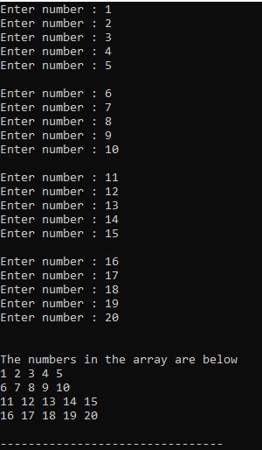

**Task 05**

**#include<iostream>**

**using namespace std;**

**struct person**

**{**

**int wagerate;**

**int vacation;**

**char status;**

**}s;**

**void disemp(struct person)**

**{**

**cout<<"Enter vacations done by employee : ";**

**cin>>s.vacation;**

**cout<<"Enter status Hourly or Salaried : ";**

**cin>>s.status;**

**if(s.status=='H'|| s.status=='h')**

**{**

**cout<<"Enter wage rate of employee : ";**

**cin>>s.wagerate; //wagerate in rupees per hout**

**cout<<"Employee daily wages are : "<<s.wagerate*12<<endl; //here i have given 12 hours for hourly workers**

**}**

**else**

**{**

**cout<<"Employee salary is : "<<30000<<endl; //i have assigned 30000 salary for salaried workers**

**}**

**cout<<"Empolyee have done "<<s.vacation<<" vacations. "<<endl;**

**cout<<"Employee status is ";**

**if(s.status=='H'||s.status=='h')**

**cout<<"Hourly";**

**else**

**cout<<"Salaried.";**

**}**

**int main()**

**{**

**disemp(s);**

**return 0;**

**}**

